Name : Arsat P
Reg No: 192424038
COURSE:ITA0609-MACHINE LEARNING

Concept Maps: Health Prediction ML System & Find-S Algorithm
Question 1: ML System Design for Disease Prediction

1. Problem Setup
We design a machine learning system to predict diseases such as heart disease or diabetes using patient data: age, blood pressure, glucose level, cholesterol, BMI, and lifestyle factors (smoking, exercise, diet, family history). This is framed as a classification task, ideally producing a calibrated risk score rather than a hard yes/no label.

2. Data Preprocessing
- Handle missing values via mean/median imputation for continuous variables, or a dedicated category for categorical ones.
- Remove duplicates and detect/handle outliers (e.g., implausible lab values).
- Encode categorical variables (one-hot encoding for smoking status, sex, etc.).
- Normalize/standardize numeric features, since age, blood pressure, and glucose live on very different scales.

3. Feature Selection
- Correlation analysis and chi-square tests to identify redundant or irrelevant variables.
- Recursive Feature Elimination (RFE) or tree-based feature importance to rank predictors.
- Incorporate domain knowledge — known clinical risk factors (e.g., fasting glucose, systolic BP) should generally be retained.

4. Algorithm Choice and Justification
- Logistic Regression: interpretable baseline; coefficients show how each factor changes risk — important for clinician trust.
- Random Forest / Gradient Boosting (XGBoost): captures non-linear interactions between risk factors; robust to outliers; provides feature importance.
- SVM: performs well on small-to-medium clinical datasets with clear class separation.
- Neural networks: only justified with large datasets; otherwise risk overfitting and loss of interpretability.
In practice, ensemble tree methods (Random Forest/XGBoost) are usually the best balance of accuracy and interpretability (via SHAP values) for tabular clinical data.

5. Model Training and Evaluation
- Stratified train/validation/test split (e.g., 70/15/15) to preserve class balance.
- k-fold cross-validation for reliable performance estimates on limited medical datasets.
- Address class imbalance using SMOTE oversampling or class-weighted loss.
- Prioritize recall/sensitivity in evaluation, since missing a true disease case is costlier than a false alarm; also track precision, F1, and ROC-AUC.

6. Reliability and Deployment
- Guard against data leakage (e.g., excluding post-diagnosis lab values from features).
- Validate on an external patient cohort before trusting the model in a new population.
- Deploy as a decision-support tool: the model provides a risk score with explanation, and a clinician makes the final call.

7. Concept Map — Disease Prediction ML System
The diagram below summarizes the end-to-end pipeline: data collection, preprocessing, feature selection, algorithm choice, training, evaluation, and deployment.
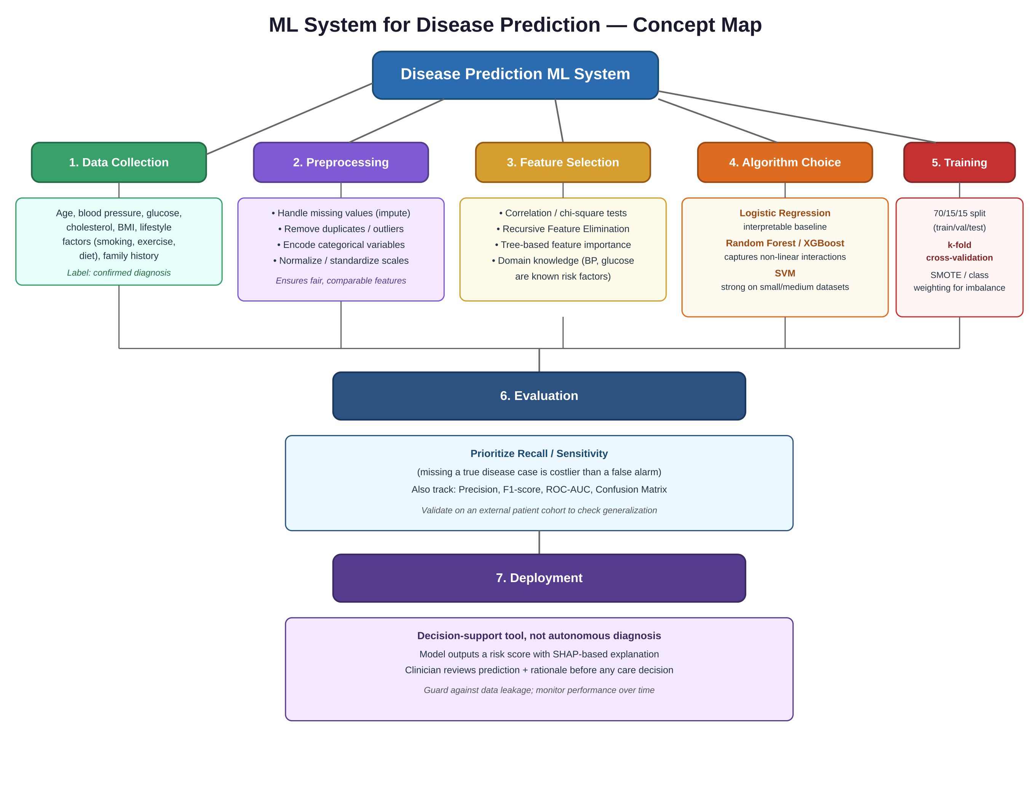

Question 2: Find-S Algorithm Applied to Loan Approval

1. Problem Setup
We are given a small training dataset that records whether a loan was approved based on four attributes: Employment Status, Salary Level, Credit Score, and Loan History. The Find-S algorithm is used to derive the most specific hypothesis that is consistent with all the POSITIVE ("Yes") training examples.

Training Dataset
Example | Employment | Salary | Credit Score | Loan History | Loan Approved
1 | Employed | High | Good | Clean | Yes
2 | Employed | Medium | Good | Clean | Yes
3 | Unemployed | Low | Poor | Bad | No
4 | Employed | Medium | Excellent | Clean | Yes

2. Find-S Algorithm — Steps
Find-S works only with positive examples. It starts with the most specific possible hypothesis and generalizes it minimally each time a positive example is not covered. Negative examples are ignored entirely.

Step 0: Initialize
h₀ = (∅, ∅, ∅, ∅) — the most specific hypothesis possible (matches nothing).

Step 1: Process Example 1 (Employed, High, Good, Clean → Yes)
Since h₀ is maximally specific and matches nothing, the hypothesis is set equal to this first positive example:
h₁ = (Employed, High, Good, Clean)

Step 2: Process Example 2 (Employed, Medium, Good, Clean → Yes)
Compare with h₁ attribute by attribute: Employment matches (Employed). Salary differs (High vs Medium) → generalize to "?". Credit Score matches (Good). Loan History matches (Clean).
h₂ = (Employed, ?, Good, Clean)

Step 3: Process Example 3 (Unemployed, Low, Poor, Bad → No)
This is a NEGATIVE example. Find-S ignores all negative examples, so the hypothesis remains unchanged: h stays (Employed, ?, Good, Clean).

Step 4: Process Example 4 (Employed, Medium, Excellent, Clean → Yes)
Compare with h₂: Employment matches. Salary matches (already "?"). Credit Score differs (Good vs Excellent) → generalize to "?". Loan History matches (Clean).
h₃ = (Employed, ?, ?, Clean)

3. Final Hypothesis
After processing all training examples, the most specific hypothesis consistent with every positive example is:
h = (Employed, ?, ?, Clean)
Interpretation: Based on the positive training examples, a loan is predicted to be approved whenever the applicant is Employed and has a Clean loan history — Salary Level and Credit Score do not affect the outcome for the examples seen so far ("?" means "any value").

4. Concept Map — Find-S on Loan Approval
The diagram below summarizes the Find-S algorithm's purpose, inputs, step-by-step generalization process, and final output for this loan-approval scenario.
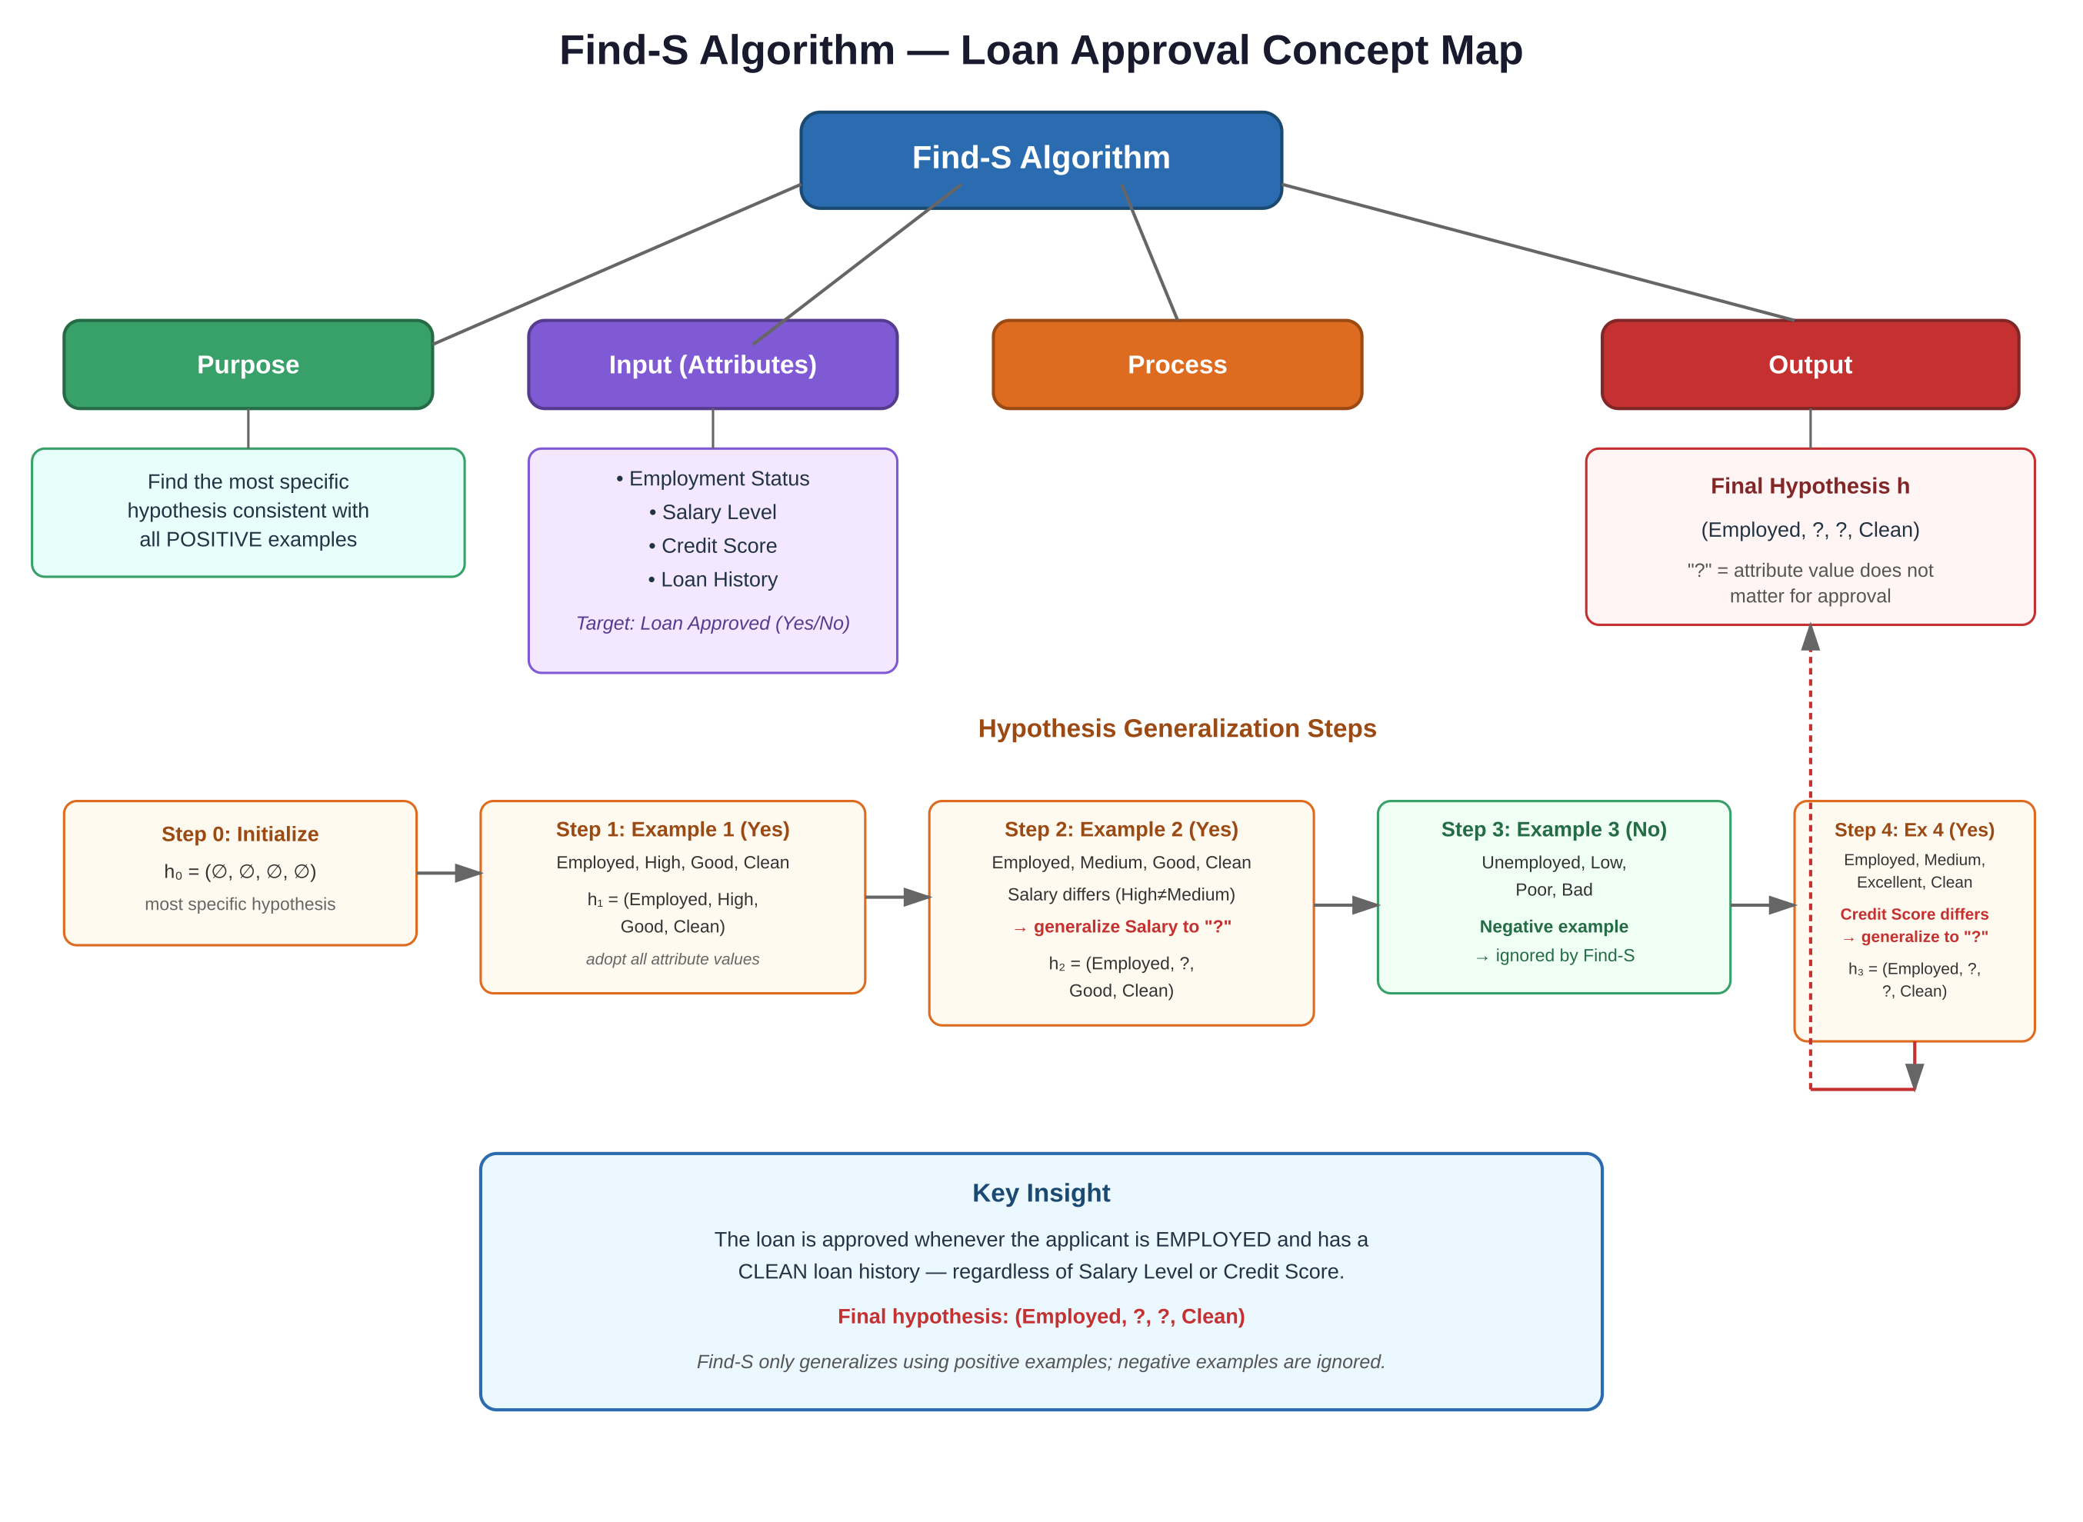

5. Notes and Limitations
- Find-S ignores negative examples entirely, so it cannot detect inconsistent data or tell us why an example was rejected.
- It always returns exactly one hypothesis (the most specific one) and cannot express uncertainty between multiple consistent hypotheses.
- It assumes the correct hypothesis lies within the given hypothesis space and that the training data is noise-free.
- The Candidate Elimination algorithm extends this idea by also maintaining the most general boundary, giving a fuller version space.

